**Neural Networks:**

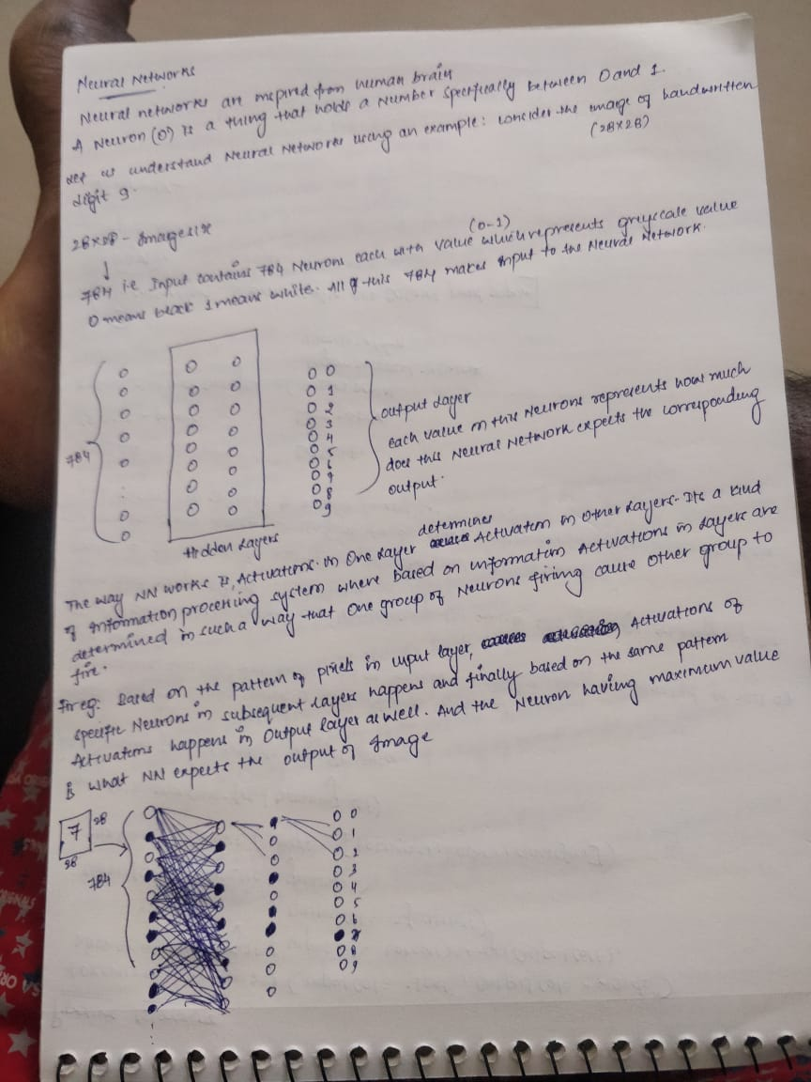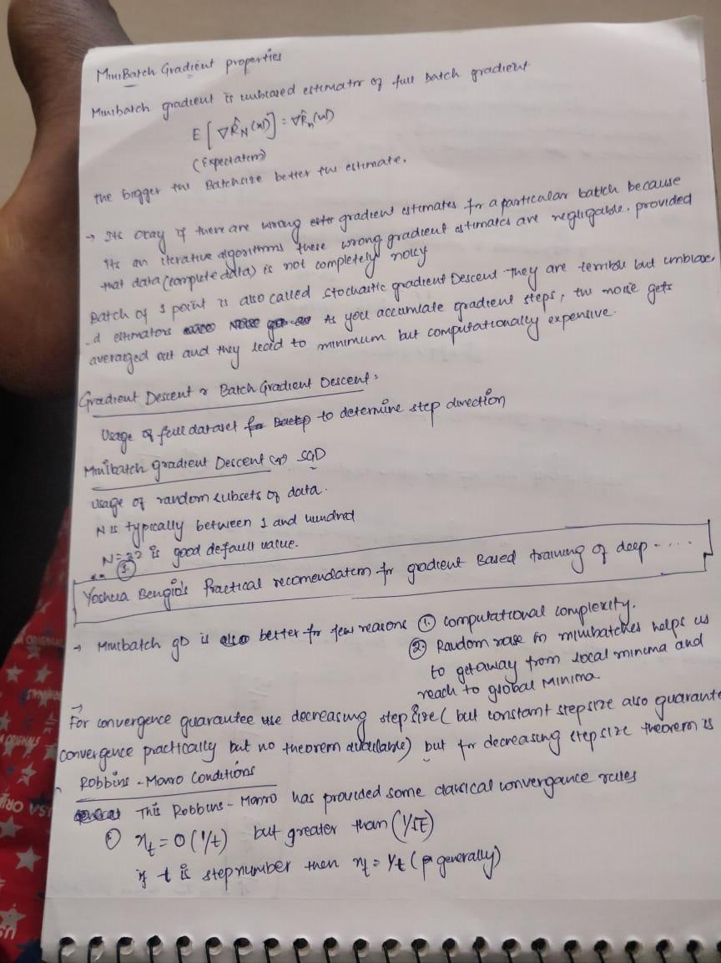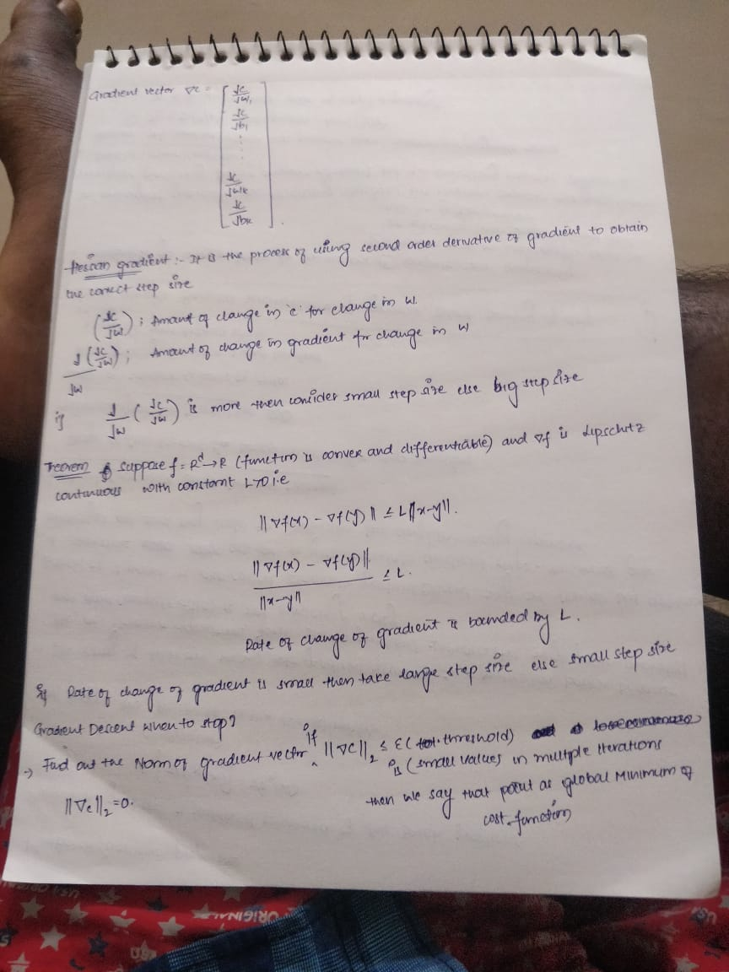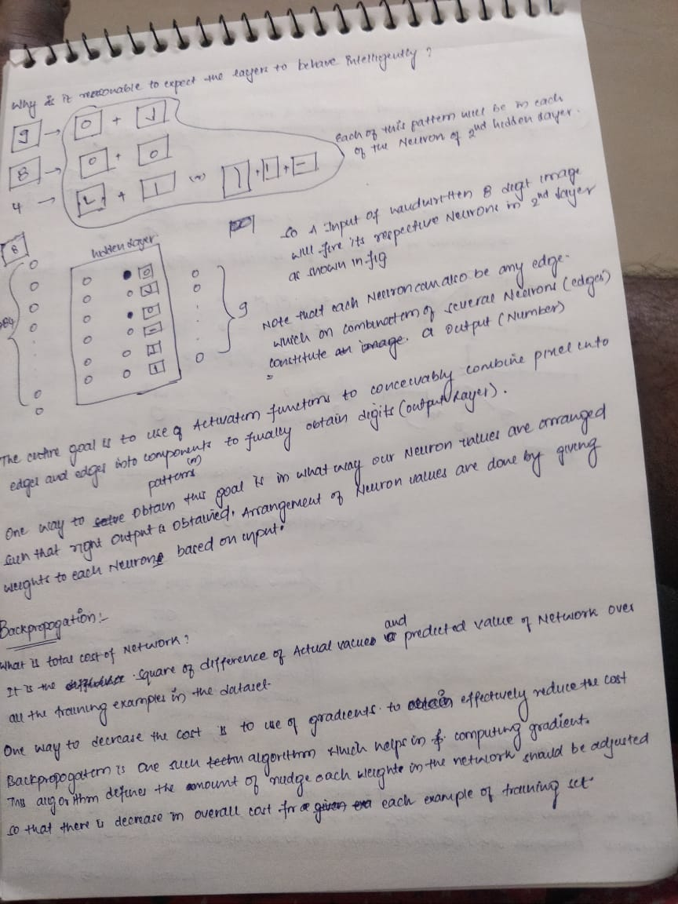

**Multi Layered Perceptron:**

**What is the use of having MLP’s?**

Answer:

1. Biological Inspiration
2. Mathematical Argument:

By using a multi layered structure, we can arrive at complex mathematical functions to solve the problem.

They are very powerful models, but they over fit easily.

**Notation of MLP:**

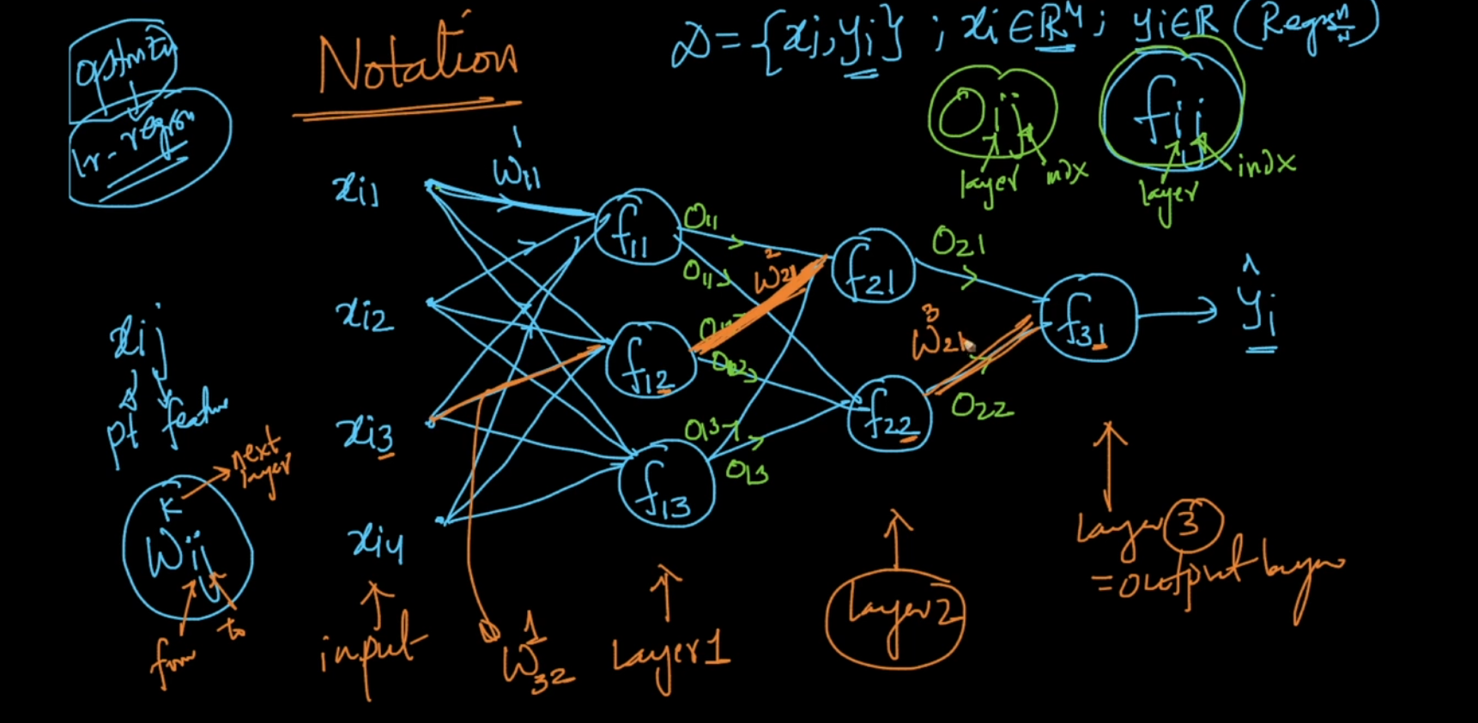

**What is model Training in neural networks?**

Training means finding the best parameter (weights and biases which have minimum loss values) by using the training data.

The process of model training involves finding out the best parameters W and b at which the cost function is minimum.

This process can be called as optimization and there are optimization algorithms like SGD or GD which leverages the concept of gradients to find the best w and b.

**SGD-Stochastic Gradient Descent:**

Step-1: The algorithm starts by randomly initializing the W’s and b’s

Step-2: Using the randomly initialized values all the datapoints(random subset of training data) are feed forwarded through the network and cost is calculated at the end of the network.

Step-3: Gradients are calculated for each weight( The effect of each W value on cost function is caculated) and by using below formulae the weights in the network are updated

Wnew=Wold –eta*Gradient(dc/dw)

Step-4: Using these new weights the random subset of training data is again feed forwarded over the network and cost calculated in last layer and again the gradient is calculated and weights are updated.

Step-5: This process is repeated iteratively whenever the loss function become very minimal and it no longer changes and settles at one particular value.

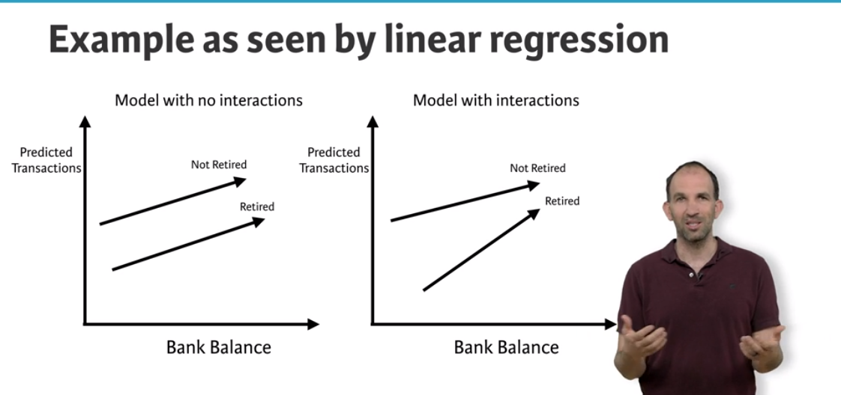

On the left is Linear model without any interactions both the lines are parallel, But in case of neural networks which allows interactions the lines are not parallel.

Neural networks accounts for interactions very well.

Deep learning uses really powerful neural networks.

**Difference of using Neural Networks:**

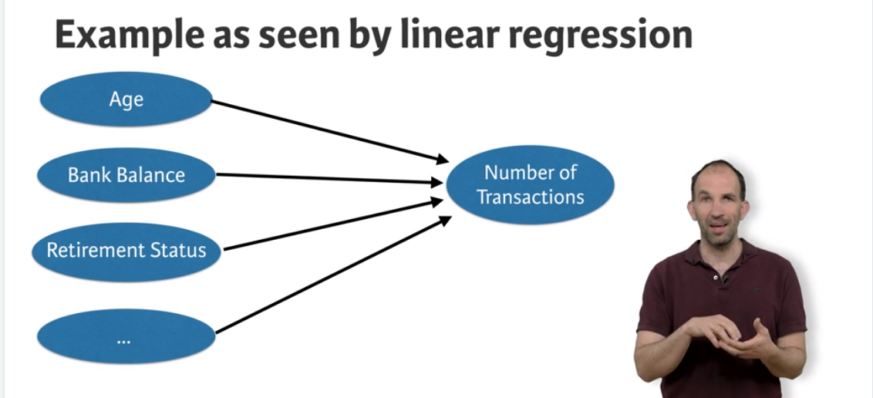

Linear regression predicts number of transactions as sum of individual features and will not consider any interaction between them.

**Whereas Deep learning captures interactions as below:**

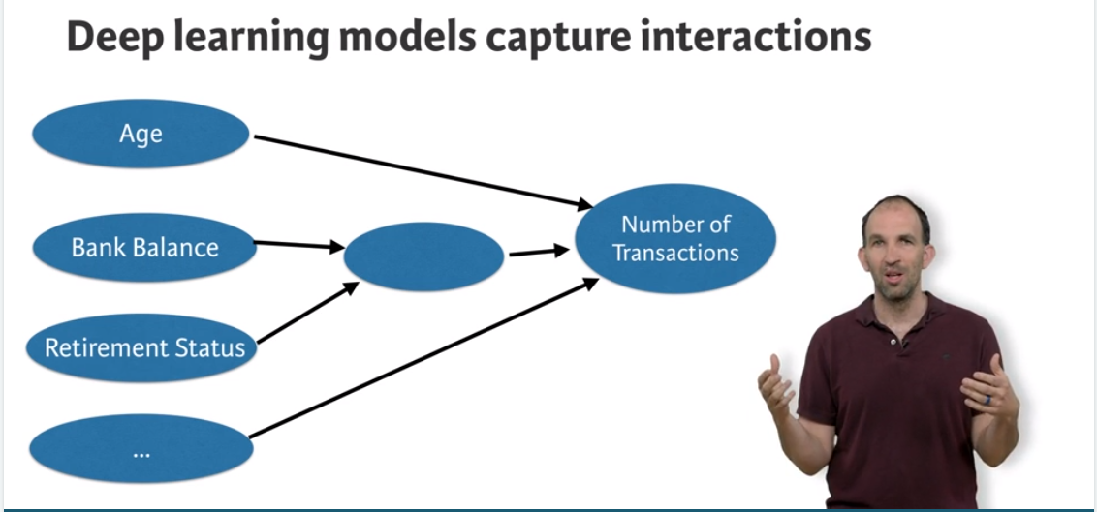

Ideally the below diagram summarises how interactions in Neural networks works.

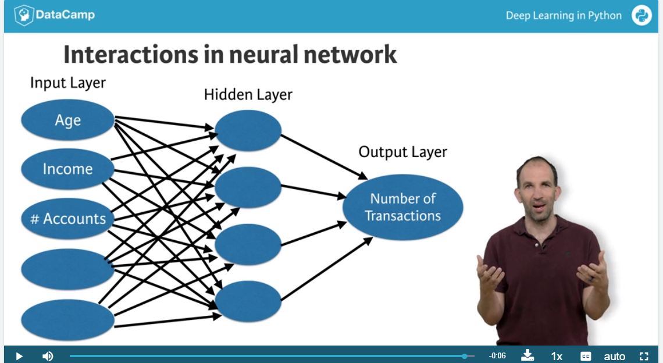

Ideally more the nodes in Hidden layer, more the interactions.

**Forward Propagation:**

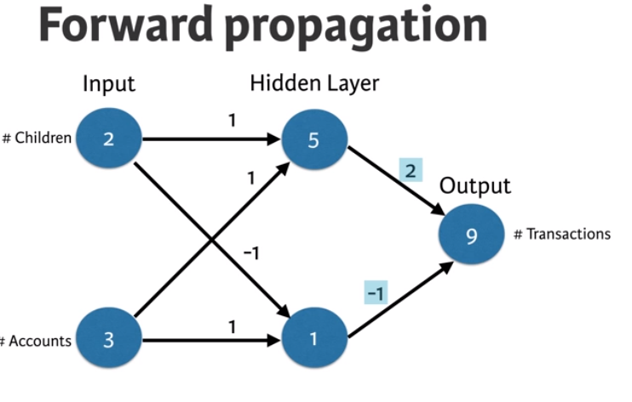

Code for above Forward Propagation:

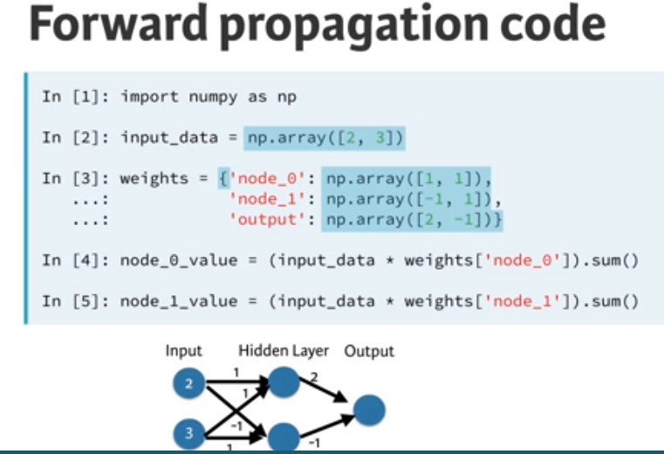

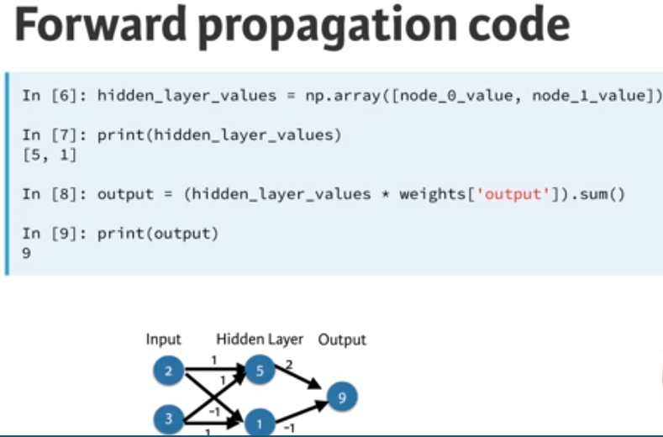

**Activation Functions:**

Activation functions are applied to each node in the Hidden network.

Usage of activation function makes neural networks more powerful by introducing non linearity to the solution.

**Deep Networks:**

Deep networks internally build representations of patterns in the data.

By using Deep Networks , Neural networks partially replace the need of feature engineering.

Subsequent layers in deep networks sophistically build robust representations of raw data.

Good thing about deep learning is the modeller doesn’t need to tell the model of interactions.

Based on the given data the model will automatically find the weights that finds the relevant patters useful for predictions.

**Back Propagation:**

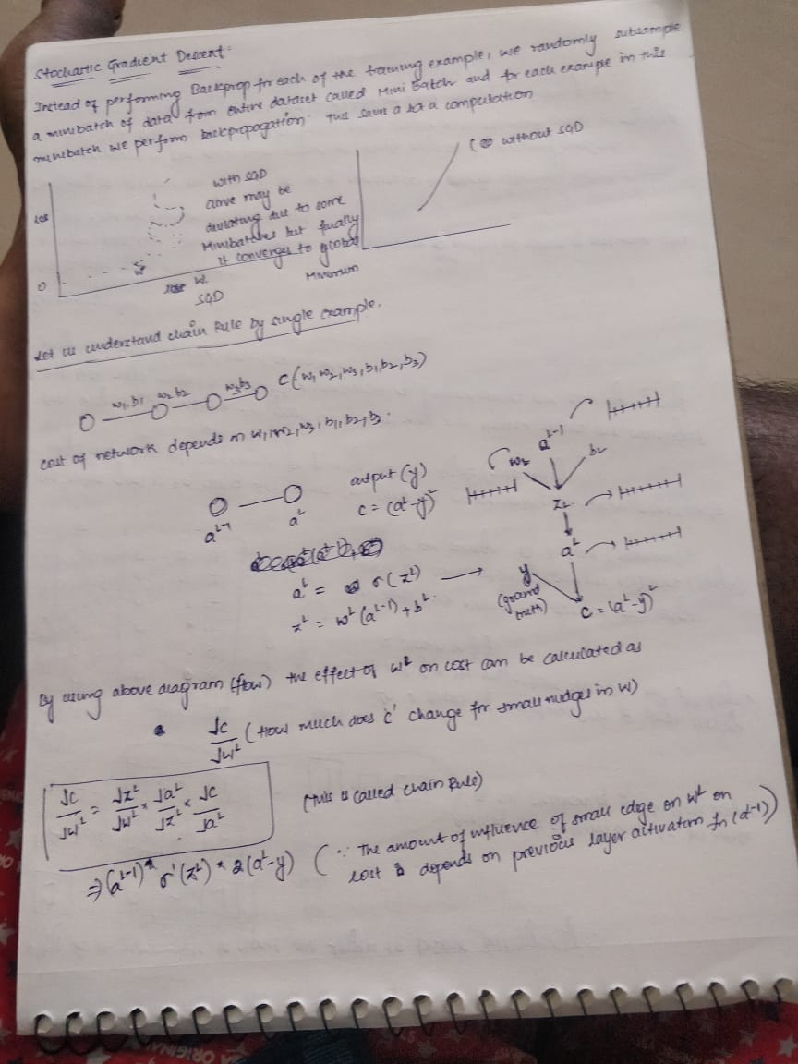

Value of gradient calculated during backprop is obtained using three terms.

1. Derivative of activation function of node for which this weight feeds into (aL node in the above diagram)
2. Activations of the node feeding into the weight (aL-1 node in the above diagram)
3. Derivative of loss function w.r.t the node it feeds into (aL node in our diagram)

Hence to obtain gradient for a weight during back prop these above 3 values are mandatory.

**Code for Gradient calculation (for example in the above image):**

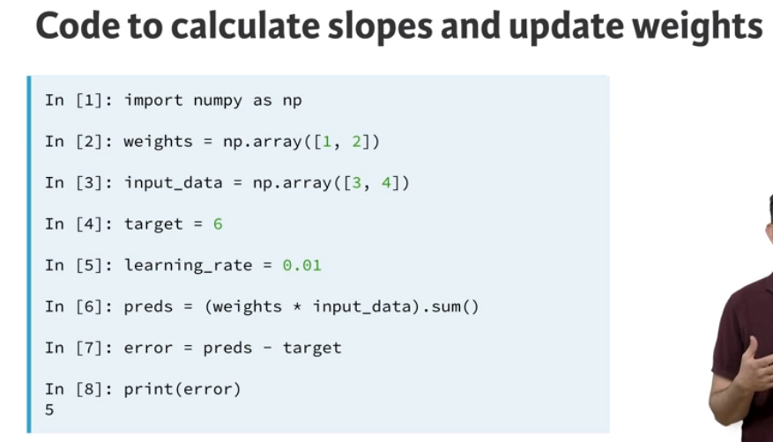

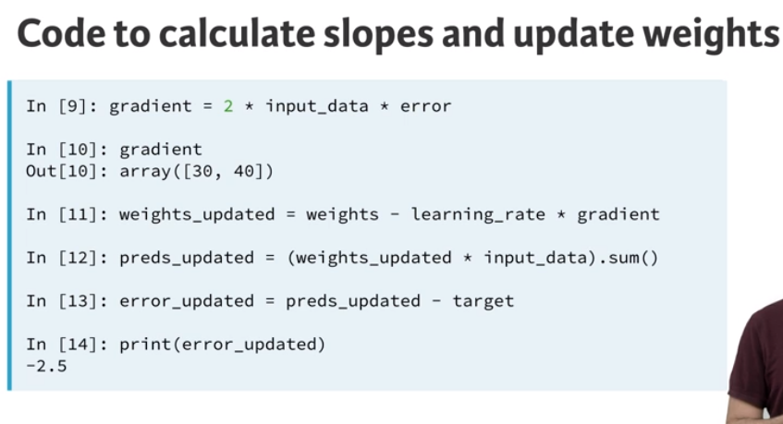

**Back Propagation in MLP’s (Applied AI ):**

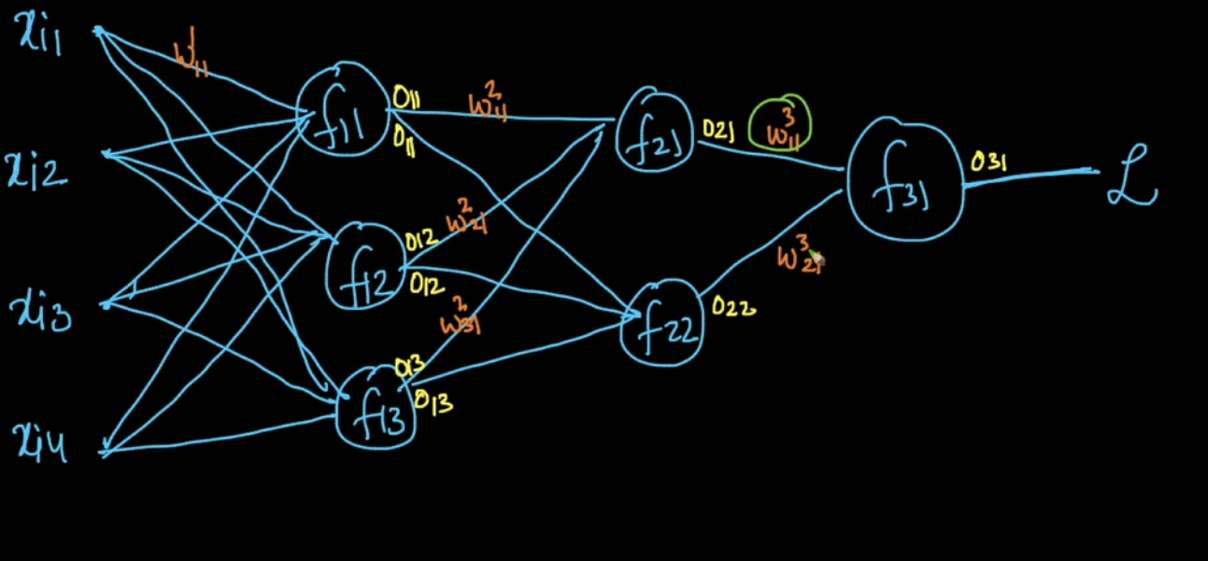

**Using Chain Rule during gradient Calculation:**

**Derivative of L w.r.t to w311 :**

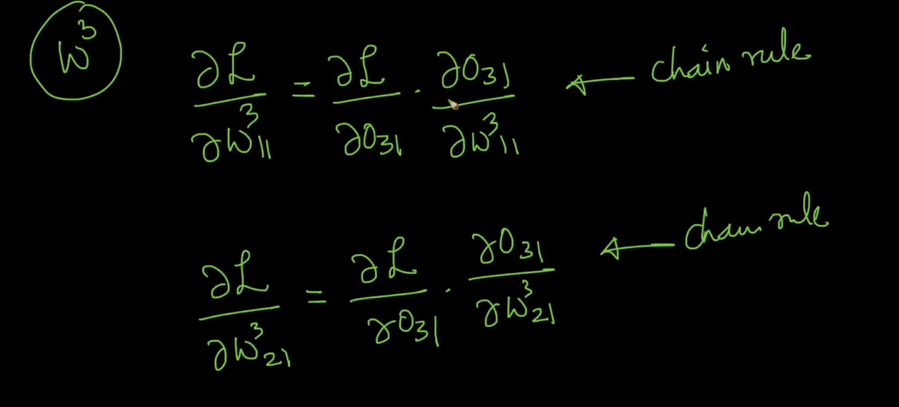

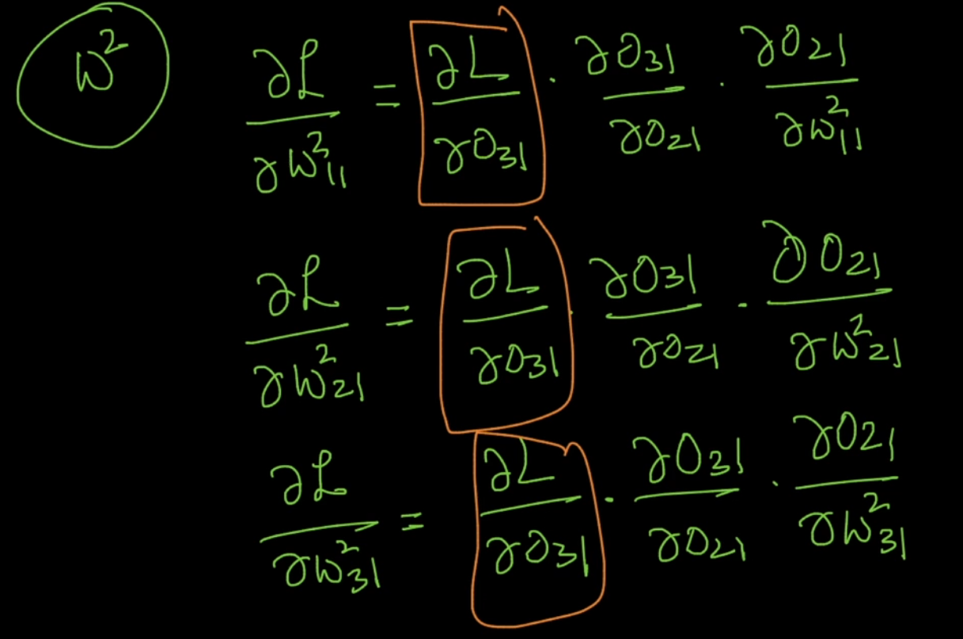

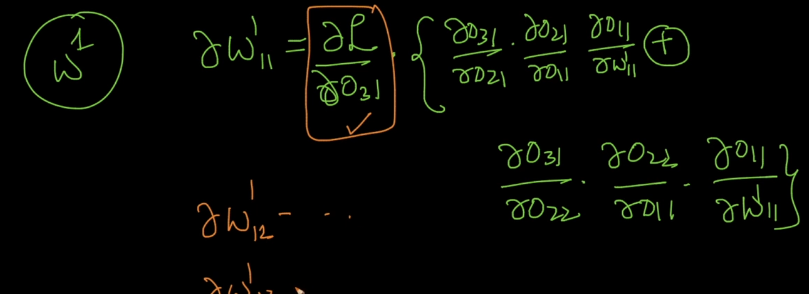

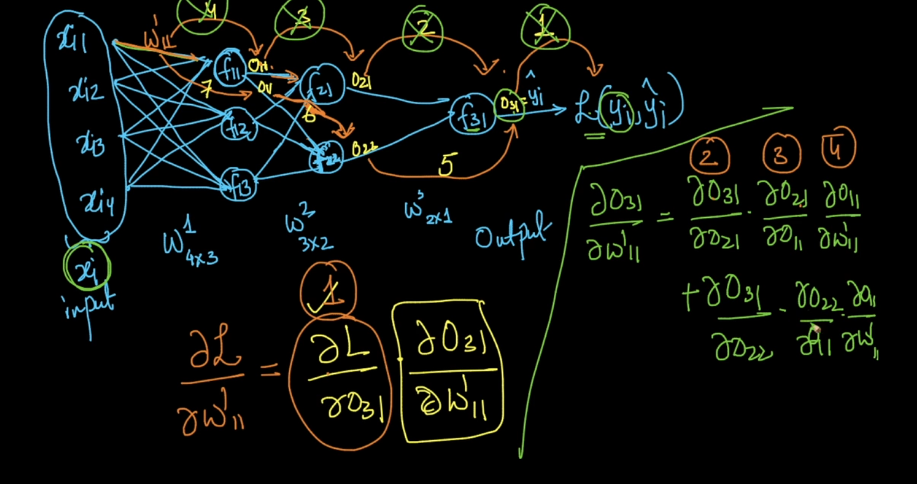

**Creating A Keras Deep Learning Model:**

**Model Building Steps:**

1. Specify the architecture.
   1. Import numpy as np
   2. From keras.layers import Dense
   3. From keras.models import Sequential
   4. Predictors=np.loadtxt(‘predictions.csv’,delimiter=’,’)
   5. n_cols=Predictors.shape[1]
   6. model=Sequentia()#There are two ways to define a model Sequential() is one such process which is easy.
   7. model.add(Dense(100,activation=’relu’,input_shape=(n_cols,)))#Dense layers means all the neurons in one layers are connected to another layer.  
      Input_shape=(n_cols,) means it can have any number of rows
   8. model.add(Dense(100,activation=’relu’))
   9. model.add(Dense(1))#output has only one node
2. Compile the model.
   1. **Specify the optimizer**(this controls the learning rate)
      1. Many options and mathematically complex
      2. Adam is usually good
   2. **Loss Function:** Mean squared error common for Regression

**Model.compile(optimizer=’Adam’, loss=’mean-squared-error’)**

1. Fit the model which involves forward and back propogation
   1. Apply back prop and gradient descent with your data to update the weights.
   2. Scaling data before fitting eases optimization

Model.fit(predictors, target)

1. Use the model for prediction.

**Classification Loss function : Categorical cross entropy**

**Softmax Activation Function :** It ensure that the predictions sum to 1 to make interpretation easy.

**Code for classification using Keras:**

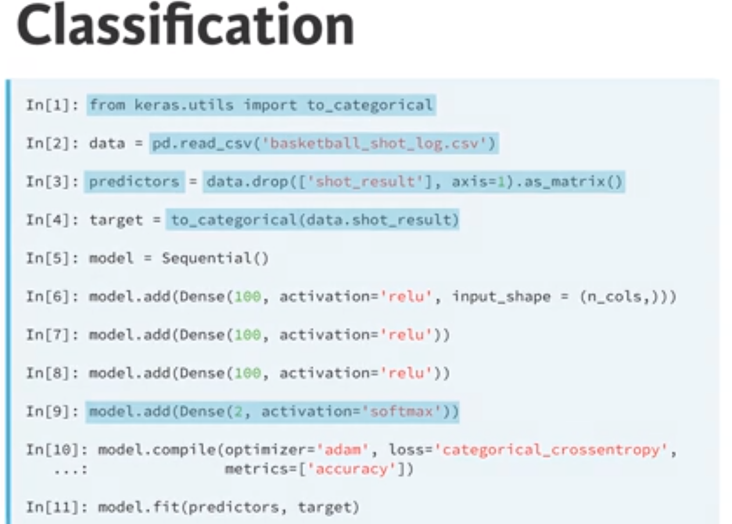

**The dying neural problem:**

Once the neuron gets a negative value , it will never turn back to positive value and it will no longer contribute to learning.

Instead of using a string value inside optimizer like ‘sgd’, the function SGD() can be used when we want to have a different lr value than the provided default value in SGD()

For eg: model.compile(optimizer=SGD(lr=0.05),loss=’categorical_crossentropy’,metrics=[‘accuracy’])

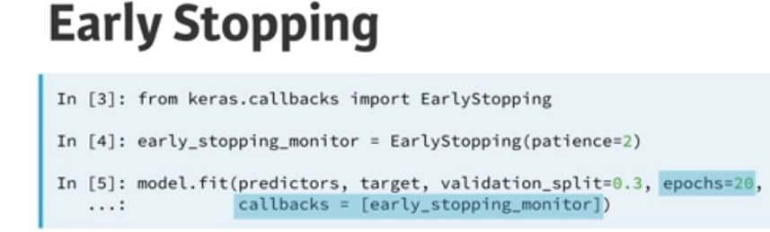

It is a neural network technique which can be used to stop NN training in case of no improvement in validation loss. Patience=3 means wait for atleast 3 epochs ad stop training if there is no further improvement. The model may increase its performance during training after 2 epochs but 3 should be a good value if model doesn’t learn anything for 3 epochs its likely that it will not improve further.

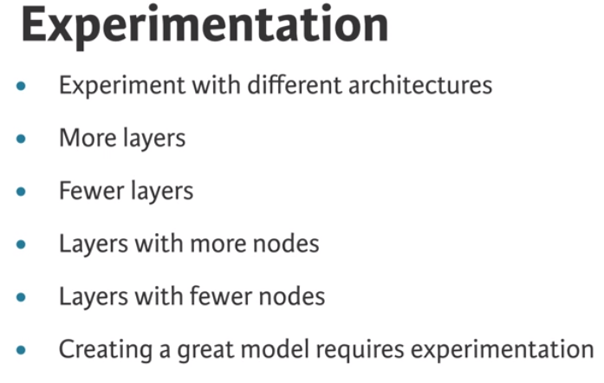

**Model Capacity or Network Capacity:**

Model capacity or network capacity is largely related to Overfitting and underfitting

Overfitting: It is the process in which model fits the odds/happenstances in the training data which will never repeat in the validation data or test set. Due to which accuracy will be high for training set and will be low for test/validation set.

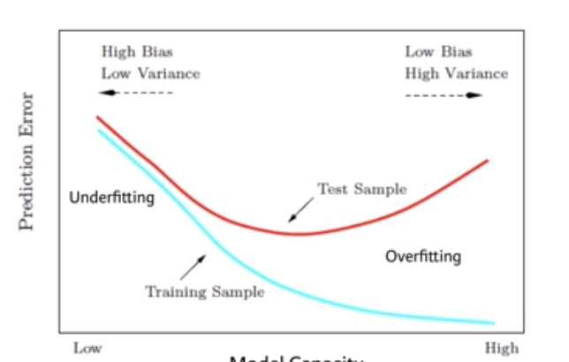

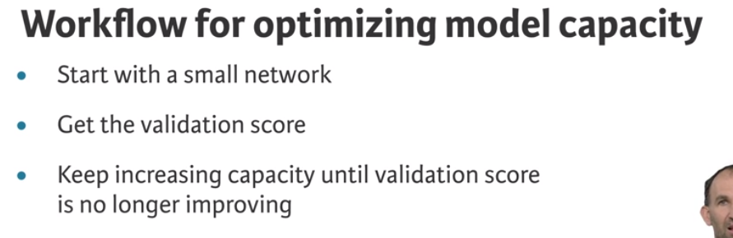

Whenever we are using Convolution Neural Network tasks it’s better to have Relu function because , as we know convolution performs linear operation hence by using relu we are introducing non linearity.

Deep neural networks are effective when we have the perfect settings.

The advantage of using Keras is that using Keras.json the backend can be changed to either of tensorflow, keras without any change in code.

Each layer in Keras is a callable object.

To add Drop out layer: model.add(Dropout(0.2))

There is a tool with Keras+hyperopt which can be used for Neural network hyper parameter fine tuning.

Deep Learning in TensorFlow(LYNDA)

**Session:** session is an object in tensorflow that runs operations on the computational graph and tracks the status of each node in the graph.

For tensorboard visualization:

Need to create log of the model training using tf.summary.writer. refer to DeepLearning->LYNDA->04->model_logging.py for implementation

Post capturing the logs open pycharm terminal or cmd and type:

Tensorboard --logdir=directory of logs without quotes

**PYTORCH**

The main advantages of pytorch are:

We can use set_trace() to perform debugging in pytorch whereas it is not possible in tensorflow we have only enable_eager_execution().

Tensors in pytorch are similar to numpy arrays, where direct operations can be performed by using pytorch tensors for Eg: np.eye(3) creates an indentity array. In pytorch similar operation can be done by using torch.eye(3)

Flexibility to move computations to gpu if required. If we want the computation to happen on GPU we can call .to(device) on the object the computation will happen on GPU(assign cuda object to device) for eg: model.to(device)(Refer to below image)

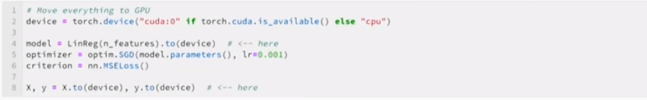

Pytorch is very flexible it can be used to perform different experimentations during training.

**Why do we need tensors why cant we use numpy arrays for Deep Learning ?**

Tensors are capable of tracking the changes within itself which are used during backpropogation or gradient calculation.

**Activation Functions:**

**Sigmoid Activation Function:**Requirements of Activation functions: Activation functions should be differentiable.

Activation functions are used to introduce non linearity among neurons

**Ronny.net(blog post on sigmoid activation)**

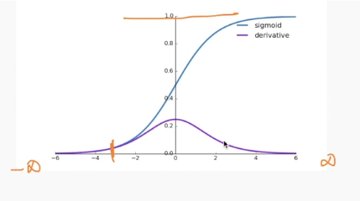

The derivative of sigmoid lies between 0 and 1.

**Tanh Function: Refer to same blogpost from ronny for tanh also .**

It is similar to sigmoid but some changes.

If the hidden layer use tanh as an activation function then the mean of activation function output will be around 0 which will make learning easier for the next layer but it will not be around 0 for sigmoid.

**Relu Activation Function:**

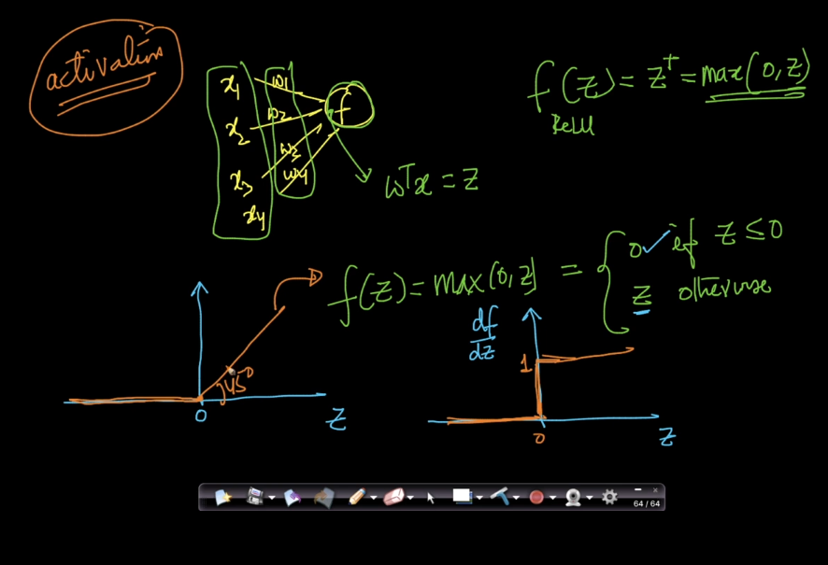

The derivative of relu function is either 0 or 1. Due to which we will not have either of vanishing or exploding gradients but since we have derivative of 0 we could have problem of dead activations.

The derivative of relu is easier to compute when compared to sigmoid and tanh.

When our Z(w*x+b) is negative, then our derivative of relu is zero. If derivative is zero then the neuron containing negative z will be a dead neuron.

We can use various initialization techniques to avoid z becoming negative.

Other versions of Relu called Noisy relu, leakyrelu(range of derivative is (small value between 0-1,1). If there are more dead neurons try leaky relu.

The main advantage of Relu over sigmoid and tanh is given a hypothesis space of parameter, less number of weights have gradient or slope equal to zero which will make learning faster because gradient is non zero.Whereas in case of sigmoid and tanh more weights will have gradients or slope as zero(refer to diagram of tanh/sigmoid where the weights having values from 0.8 to 1 have gradients or slope equal to zero)

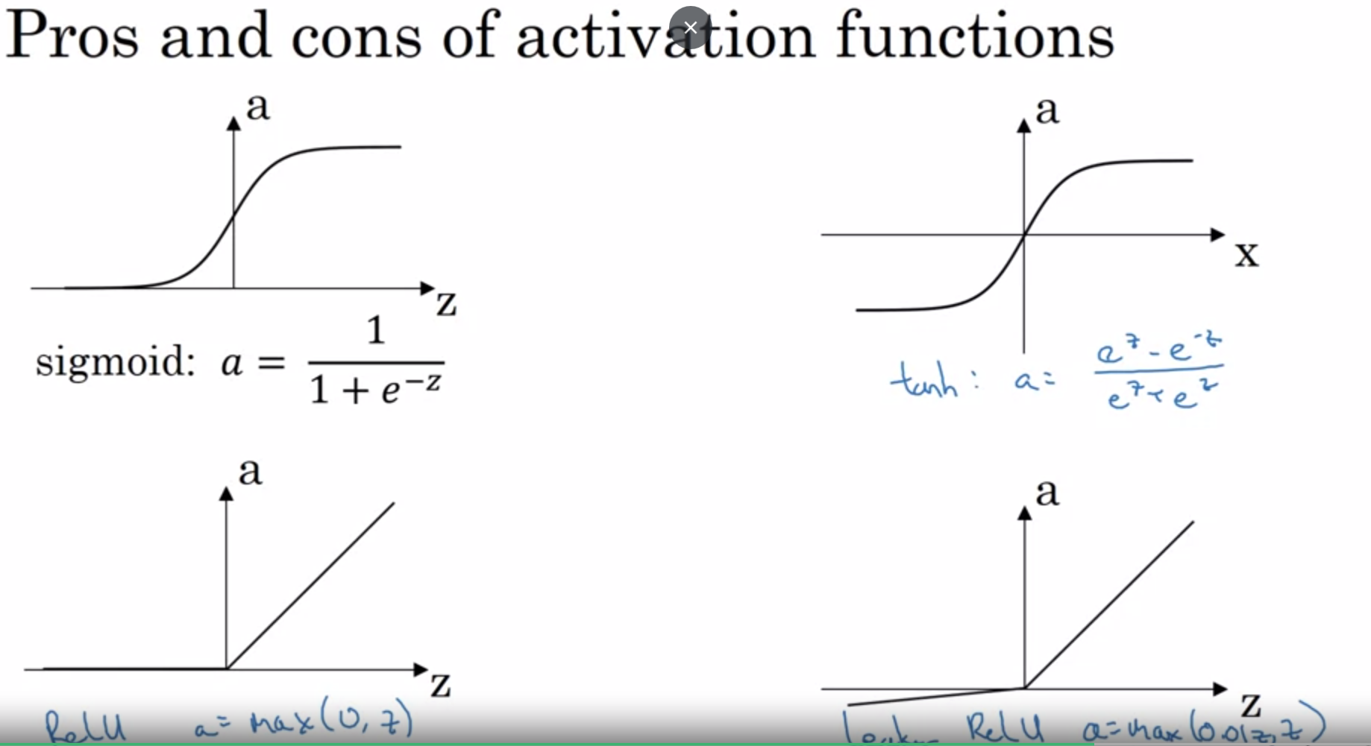

Why do you need non-linear activation functions?

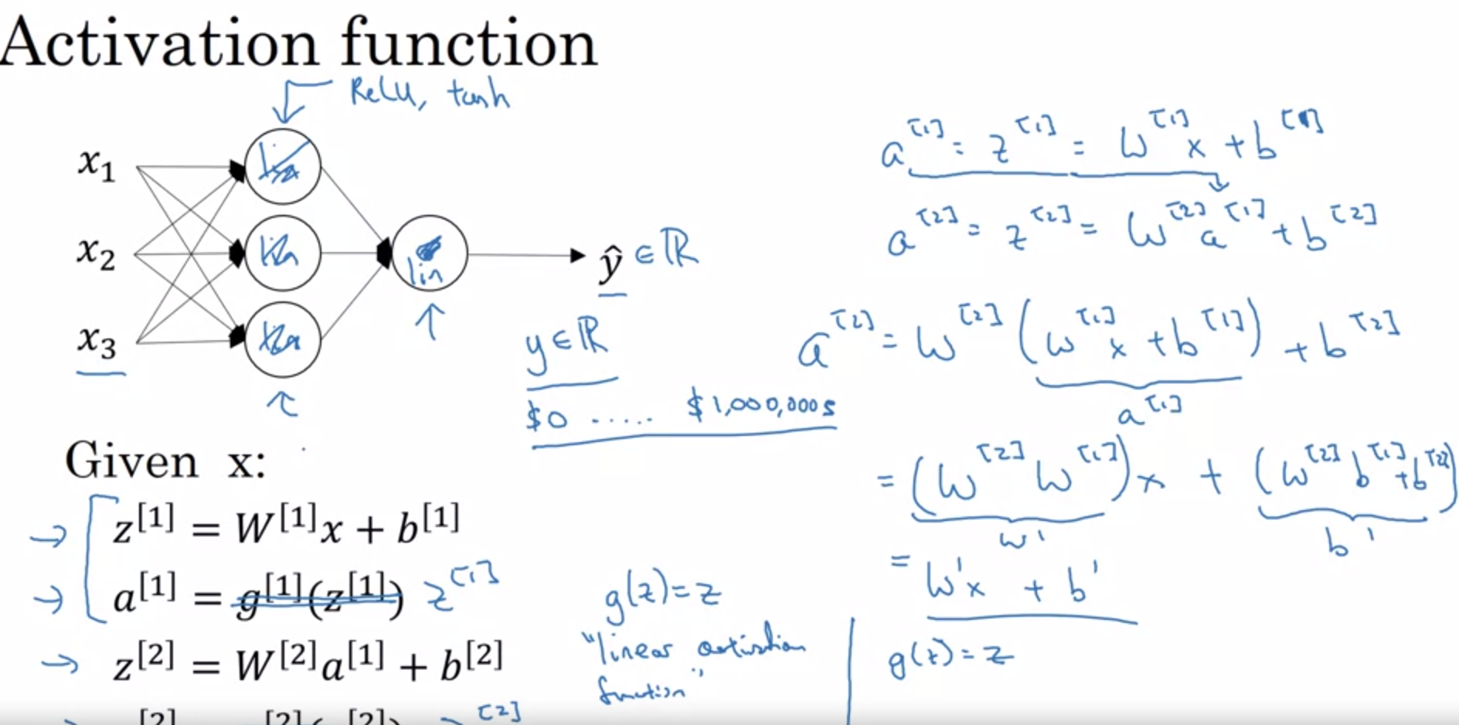

**Vanishing Gradient Problem:**

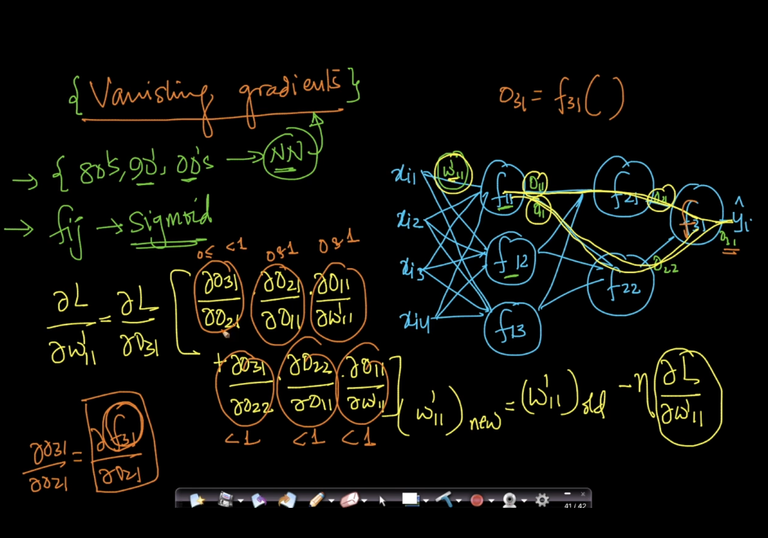

As we see in above diagram, When we use chain rule back prop the gradient of cost function w.r.t first layer weights is multiplication of various values which are in range(0,1) due to which the final gradient of cost w.r.t to initial layer weight is very less . Due to which there will not be much change in our weight value(below image).

If there is no change in our weights there will not be much learning in the initial layers.

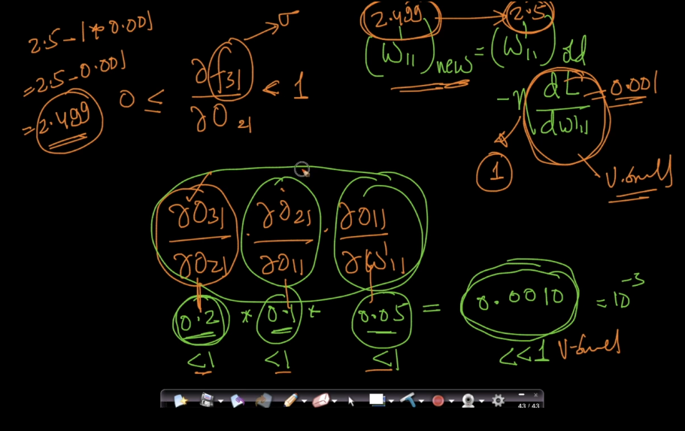

This problem is more evident with Sigmoid/Tanh activation functions as the range of derivatives of sigmoid and tanh is between (0 and 1). SO to overcome this problem we use Relu or Leaky Rule or perform Gradient Clipping.

Similar to vanishing gradient problem we have exploding gradient problem which is more evident in RNN.

**Weight Initializations:**

* What if we have all our weights to a 0 value to start with?
* In such learning will be 0
* All gradient updates will have same value.

**Properties of ideal weights?**

* Weights should be small(not too small)
* Not all weights should be zero.
* The weights should have good variance. More variability they have better the weights.
* Ideal weight distribution: Normal distribution with mean 0 and small variance.(This contains some positive and negative and it works well)

**Better Initialization Strategies:**

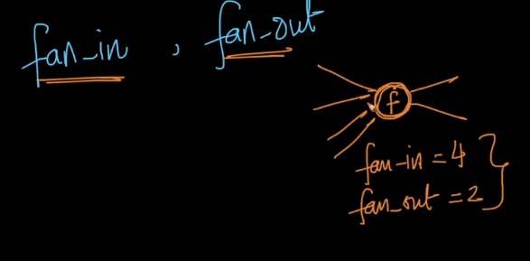

These initialization techniques depends on fan-in and fan out.

**Uniform-initialization(works well for sigmoid):**

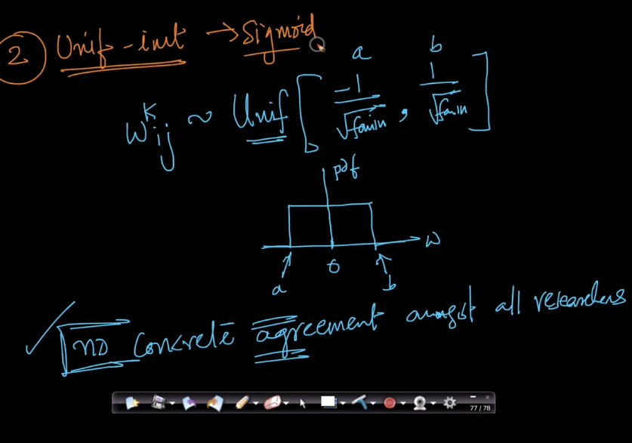

**Xavier or Glorot Initialization(works good for sigmoid,tanh):**

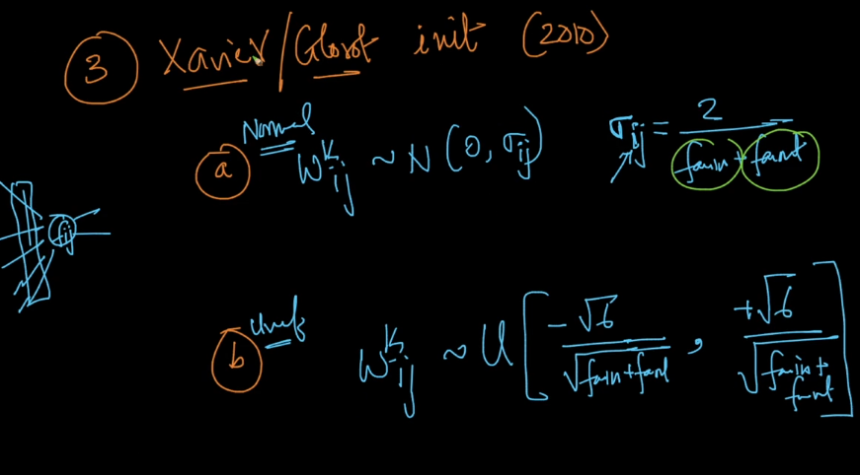

**He initialization(Works good for Relu and Leaky Relu):**

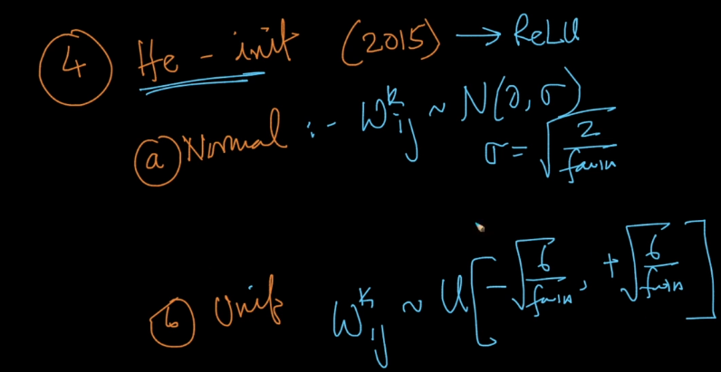

**Batch Normalization:**

This process is much useful in case of Deep Networks.

Assume a Minibatch SGD setup , In case of deep neural networks a small change in input data point will cause a large change in later layers.(as shown in below image a input of 1.01 when it reaches layers 5 it increases by 37%)  
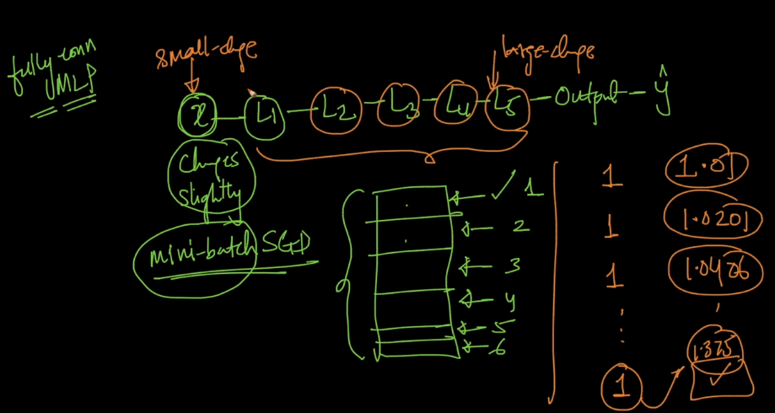

Even thought the input data is normalized , but we can still see that a small change in input data batches we can see large change in input when it reaches layer5 or deep nn layers. Hence for each batch the values at layer 5 or deep layers change significantly. This problem is called internal covariance shift.

This problem can be solved by using a batch normalization layer in deep layers.

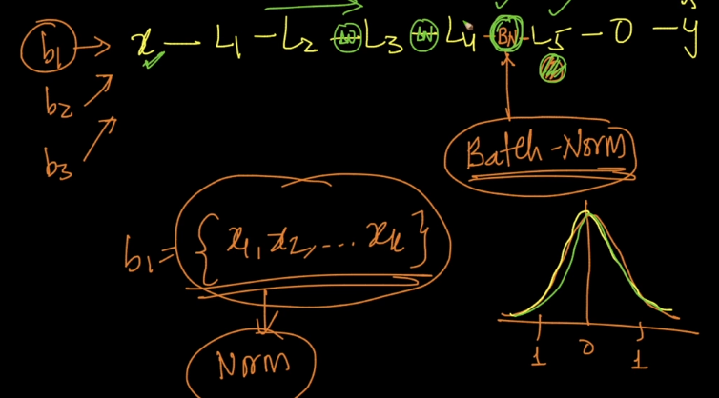  
This problem can be solved by using Batch normalization layer as shown above.

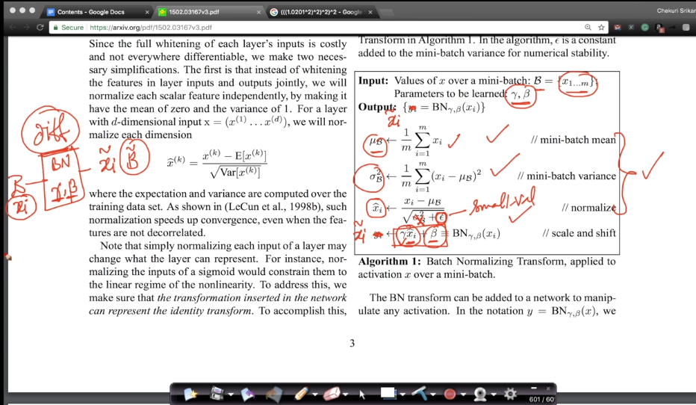

Batch normalization hyperparameters gamma and beta are learned during backprop because they can be differentiable.

**Advantages:**

Faster convergence.

We can afford to have larger learning rate.

It also acts as weak regulrizer include drop outs as well

Avoid internal covariate shift.

**Optimization process**

Slope is zero at maxima and minima.

**Mathisfun.com/maxima-minima**

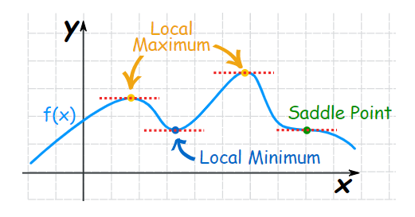

* If gradient is zero that means its either of Local maximum, local minimum, saddle point.
* There are chances that Minibatch-SGD could get stuck at saddle point.
* For convex functions localminima=global minima
* There is mathematical proof that logistic regression, linear regression, SVM(al forms) the loss is convex function for these cases.
* For deep learning loss is non convex and there may be many local minima’s and based on initializations we could land up at different minimas.
* We can understand 3d optimization plots with contour plots .
* Contour plots are circles such that points inside the contour have same loss value

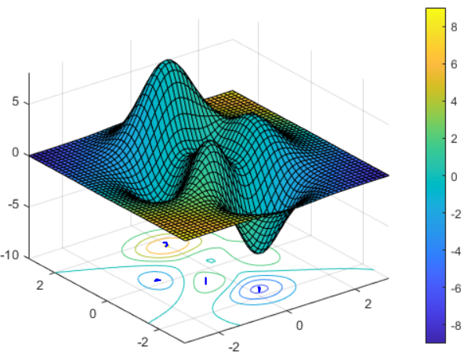

In the above plot each dot represents a local minimum and each each contour plot signifies points with same loss function.

**SGD with Momentum**

The gradients calculated using SGD are noisy because we take a batch of data points for sgd and those batch may have noisy data. Hence to avoid noisy updates we use SGD with momentum.

While updating each weight during backprop , the previous iterations gradients are also weighted and used for current weight updation.

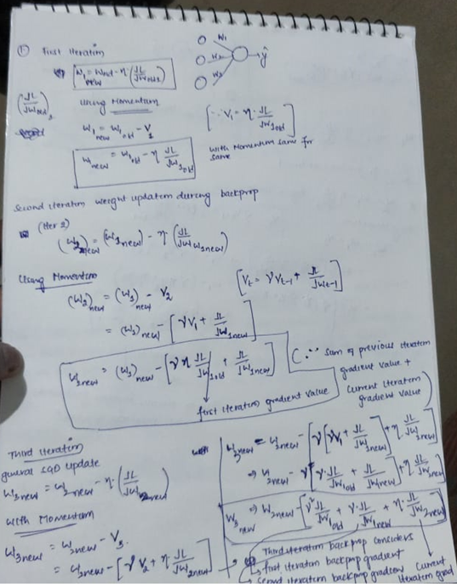

The entire process will help in denoising the gradients and speed up the convergence.

More information in blog by Sebastian Ruder.

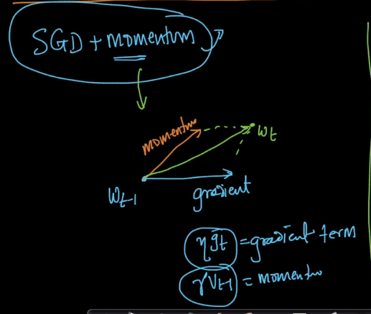

**Nestrov Accelerated Gradient (NAG)**

In SGD with momentum we add our momentum with our gradient and then move in the resulting direction , But in this method we first move in direction of momentum and then the gradient is calculated with respect to new weight value.

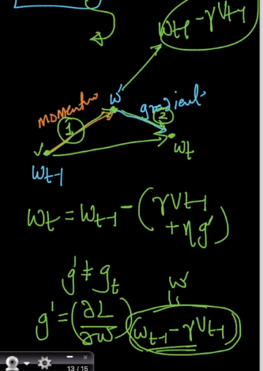

**Adagrad(Adaptive Gradients)**

The main idea behind adagrad is to have different learning rates for different weights.

But how will having different learning rates to different weights work out?

It is useful in case of sparse features, because sparse features tends to have different behaviours and using of same learning rates will not help in understanding this behaviour.

Adagrad tries to adaptively derive a learning rate in such a way that as iteration number increases learning rate decreases to avoid overshooting problem.

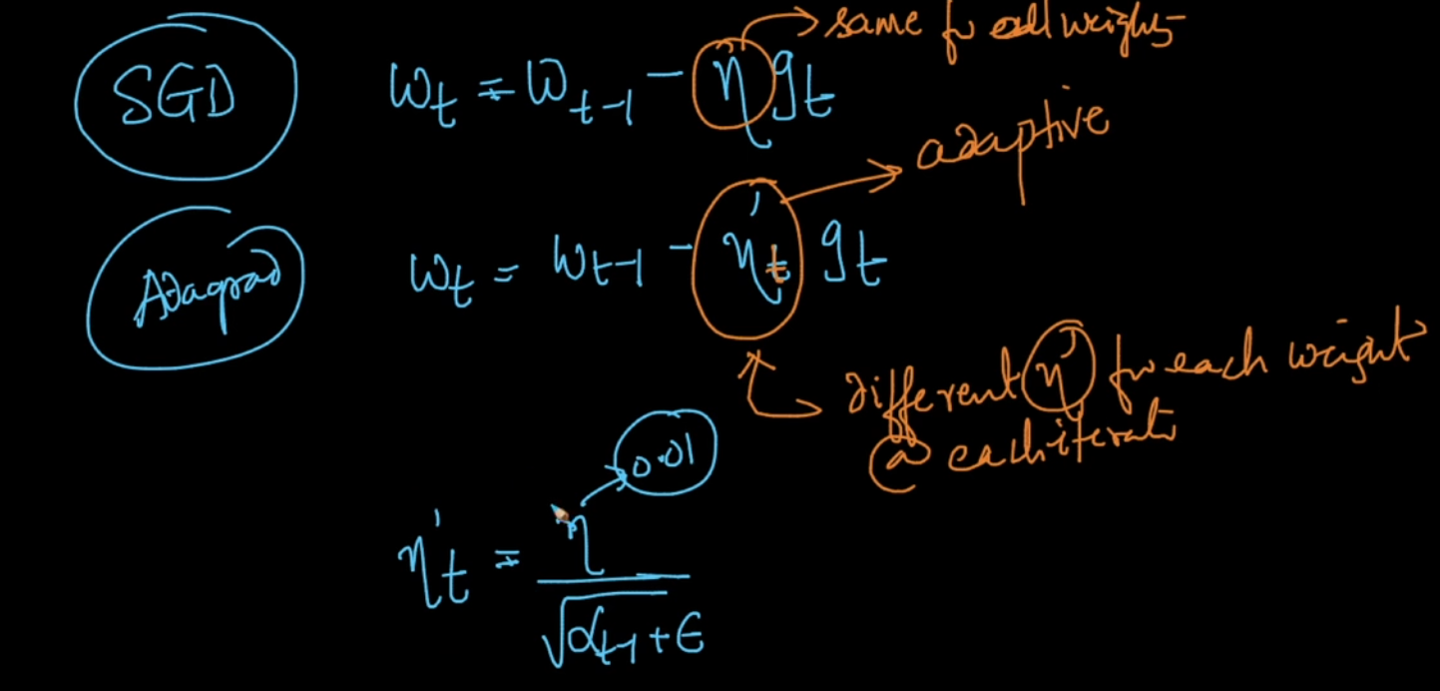

As shown in the above image, new learning rate eta-dash at t iteration is obtained. The epsilon above is a small positive number to avoid division by zero error.

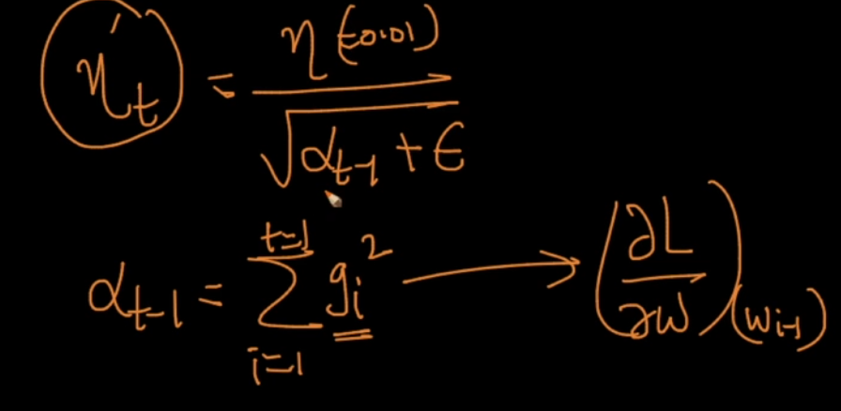

In the above image alpha(t-1) is equal to sum of squares of all the gradients (gi here means gradient) available till previous iteration.

From the above equation of etadash-t we can tell that as the number of iterations increases, the alpha t-1 increases which leads to decrease in etadash-t which should be the ideal case to deal with overshooting problem.

Hence as the iteration number increases the learning rate is reduced adaptively by using previous gradients of that particular weight.

Note that new learning rate is calculated for each weight during each iteration by using above formulae.

This will reduce the effort of manually fine tuning learning rate

One disadvantage of using this method is, alpha(t-1) increases very large which leads to very small eta dash(t-1) in case of large iterations.

Due to this small eta dash(t-1) , this could lead to slower convergence as the step size will be very small.

**Adadelta and RMSprop**

The main disadvantage of Adaptive gradients is alpha(t-1) becoming very large with increase in iterations due to which learning rate becoming very very low.

Alpha (t-1) is sum of squares of gradients till previous iterations, but adadelta works in such a way that instead of taking sum of squares of all gradient it consider exponentially decaying weights as shown below.

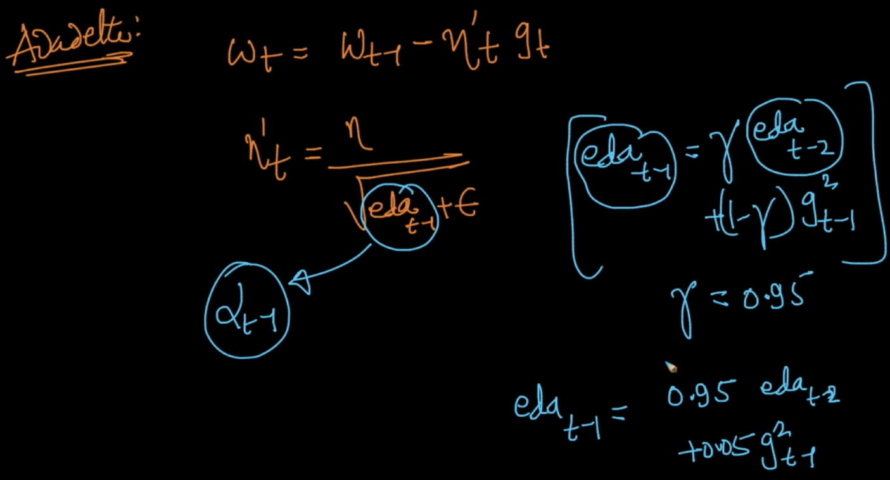

Exponential decaying gradient average means more weightage given to previous gradients and weightage is reduced exponentially there on to previous-1 gradients as shown below.

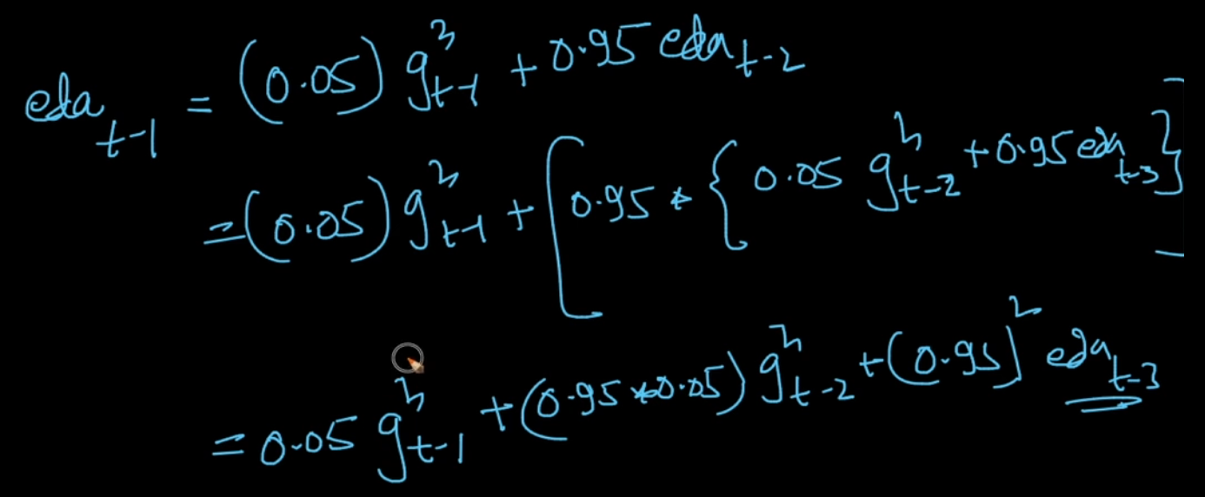

As seen above Exponentially decay average of gradients at iteration t equal to 0.05* gradients square at t-1 iteration + 0.95*0.05*gradient square at t-2 iteration and so on…

By doing so we are controlling the value of alpha (t-1) so that it does n’t become very very large to avoid slower convergence.

**Adaptive Moment Estimation(Adam)**

Not clear refer to video in Applied AI course material.

**Softmax Classification**

When it’s a binary classification problem we use logistic regression and in case of multi class classification problem we use OneVsRest Approach.

Instead of using OneVsRest we use softmax classification.

Cross entropy is used to estimate how well the prediction distribution is matching the target class.

Softmax= e^x/sigma(e^x), inputs to softmax function are activation value of each neuron in the last layer and using this input the final predicted class is obtained.

**Convolution as Edge Detection:**

Edge is obtained whenever there is a difference in colour.

Convolution is generalization of dot product( element wise multiplication followed by addition).

**Convolution Operation output formulae:**

When image shape is n*n and convolution filter size is k*k , then the output of convolution is (n-k+1)*(n-k+1)

For eg: for a 6*6 image with 3*3 kernels, then output is (6-3+1)*(6-3+1)=4*4

Every filter will have one bias

**With Padding:**

For an image with n*n shape if we apply padding operation by adding rows and column then shape becomes n+2*n+2

The output size changes with padding value. Hence for an input image with size n*n, kernel of size k*k, with padding=1 the output image size is (n-k+2p+1)*(n-k+2p+1)

**Why padding and what is the use of padding** ?

Consider a 5*5 image , when we are performing convolution on this image without any padding,

**Drawbacks 1:**

The image size shrinks for each of convolution for eg: for this 5*5 image with 3*3 kernel convolution output is 3*3(decreased when compared with original size).

**Drawback 2:**

First row first column pixel is used for convolution only once whereas a pixel value in 3rd 3rd column or any column except in first and last rows are used multiple times for convolution, similarly last row last pixel value is only used once for convolution operation this may lead to less importance given to corners or edges of the image.

Hence padding can be used to give equal importance to all the pixels and to preserve the pixels on corners or on the edges of the images.

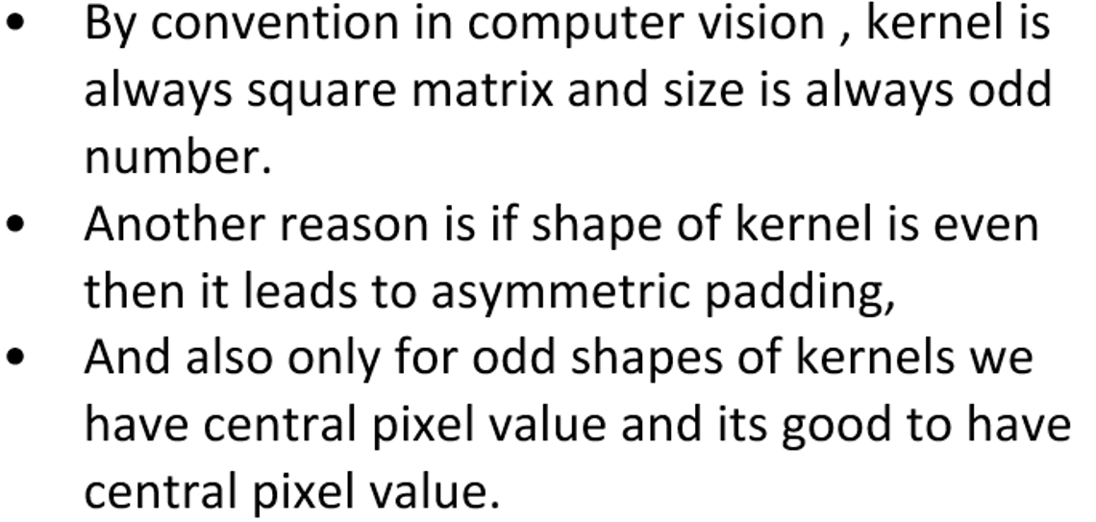

**Answer for above question from Karapathy: As the number of convolution layers increases the image size decreases significantly and after after some large number of convolution layers we will be left with image of very less size which are few numbers representing our input image and this much of information compression may not help in understanding the objects in the image.**

**Why do we need always 0 in padding ?** Because a non zero value will interfere in the computation and we may loose our original input image pixel value.

**Why convolution ?** Because they all share weights and they have local connectivity where as in Feed forward networks we don’t have local connectivity and they don’t share information.

**Striding:**

The amount of shift we are taking during convolution.

Striding helps in reducing the size of output more than how convolution is reducing the output.

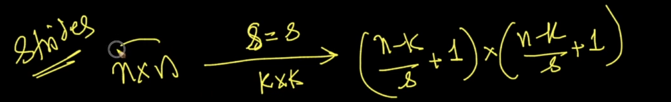

Note that the division result is rounded to next integer using floor.

With padding p, kernel size k*k, striding s, input image of size n*n then output is :

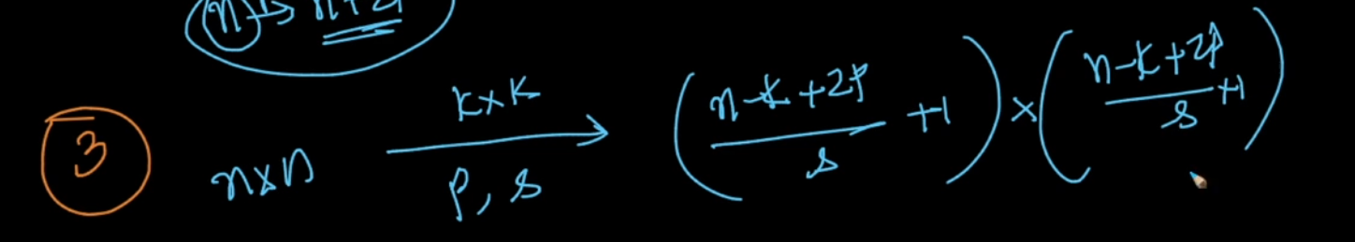

**RGB images:**

These are colour images with each pixel having 3 values , one for each of Red pixel , green pixel and blue pixel values.

A colour image is a 3D tensor.

If we want perform convolution on a colour image then the depth of kernel should be equal to depth of the image (number of channels).

Similarly if we perform one convolution using a kernel the output what we get is 2 dimensional image with shape (n-k+1)*(n-k+1).

The number of channels or depth of output depends upon the number of kernels we are using. If number of kernels are 2 then we get (n-k+1)*(n-k+1)*2

Similarly if the number of kernels are m then the output size will be (n-k+1)*(n-k+1)*m

**Convolution Layer**

There are 3 steps in one convolution layer.

Step1: Perform convolution using k*k kernel

Step2: Perform element wise activation using Relu or some activation functions (to introduce non linearity because convolution is linear operation).

**Interview question on Convolution Layer:**

Prefer a stack of small filter CONV to one large receptive field CONV layer. Suppose that you stack three 3x3 CONV layers on top of each other (with non-linearities in between, of course). In this arrangement, each neuron on the first CONV layer has a 3x3 view of the input volume. A neuron on the second CONV layer has a 3x3 view of the first CONV layer, and hence by extension a 5x5 view of the input volume. Similarly, a neuron on the third CONV layer has a 3x3 view of the 2nd CONV layer, and hence a 7x7 view of the input volume. Suppose that instead of these three layers of 3x3 CONV, we only wanted to use a single CONV layer with 7x7 receptive fields. These neurons would have a receptive field size of the input volume that is identical in spatial extent (7x7), but with several disadvantages. First, the neurons would be computing a linear function over the input, while the three stacks of CONV layers contain non-linearities that make their features more expressive. Second, if we suppose that all the volumes have CC channels, then it can be seen that the single 7x7 CONV layer would contain C×(7×7×C)=49C2C×(7×7×C)=49C2 parameters, while the three 3x3 CONV layers would only contain 3×(C×(3×3×C))=27C23×(C×(3×3×C))=27C2 parameters. Intuitively, stacking CONV layers with tiny filters as opposed to having one CONV layer with big filters allows us to express more powerful features of the input, and with fewer parameters. As a practical disadvantage, we might need more memory to hold all the intermediate CONV layer results if we plan to do backpropagation.

**Another tip on removing FC layers is to have Average pooling layers in such a way that if we have 7*7*512 as ouput of last convolution layer then it will be converted to a column with 512 rows where each row represents Average pooling of each 7*7 feature map**

**Batch Normalization and dropout can be used interchangeably because they both yield the same result. RESNET uses batch normalization instead of Dropout to avoid overfitting.**

**Why do we need to perform multi-level convolution operations?**

IF we look at the kernels at the initial layers and visualize them they look like edge detectors, whereas the kernels in the later layers on visualizing kernels we can see kernels are learning how to identify objects like blobs or circular objects like tyres in car , or even the more later layers can capable objects like flowers or cars or human faces hence we need multi level convolution operations.

**Dilated Convolution Layer:**

More about dilated convolution layer in <http://cs231n.github.io/convolutional-networks/#pool>

**More about pooling:**

It is worth noting that there are only two commonly seen variations of the max pooling layer found in practice: A pooling layer with F=3,S=2F=3,S=2 (also called overlapping pooling), and more commonly F=2,S=2F=2,S=2. Pooling sizes with larger receptive fields are too destructive.

**BlurPool- Blurpool**

**MaxPooling:**

Maxpooling works in such a way that given an image it will look for the higher value in that position . This makes it very less sensitive to position. This is very helpful when we have objects positioned left or right or anywhere , maxpool helps us identify them.

Applied AI:

Max pool helps in identifying edge without any location invariance. Suppose we have a face or edge in an image . Irrespective of the position of where the object is in the image it will find out whether there is any edge or face in the image. Hence the name location invariance.

**Stanford on Pooling Layer:**

It reduces the spatial size of the input volume which reduces the computations and parameters.

It helps in dealing with controlling overfitting.

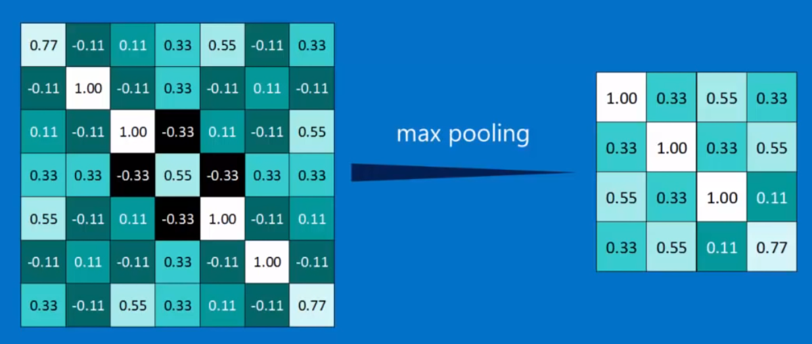

Maxpooling tries to downsample the image , by keeping the pattern in the image undisturbed. For eg: higher pixels are available in the diagonal line of the image , post max pooling the higher pixels are still available in the diagonal line.

The below image shows that max pool down samples the images while retaining the pattern in the image.

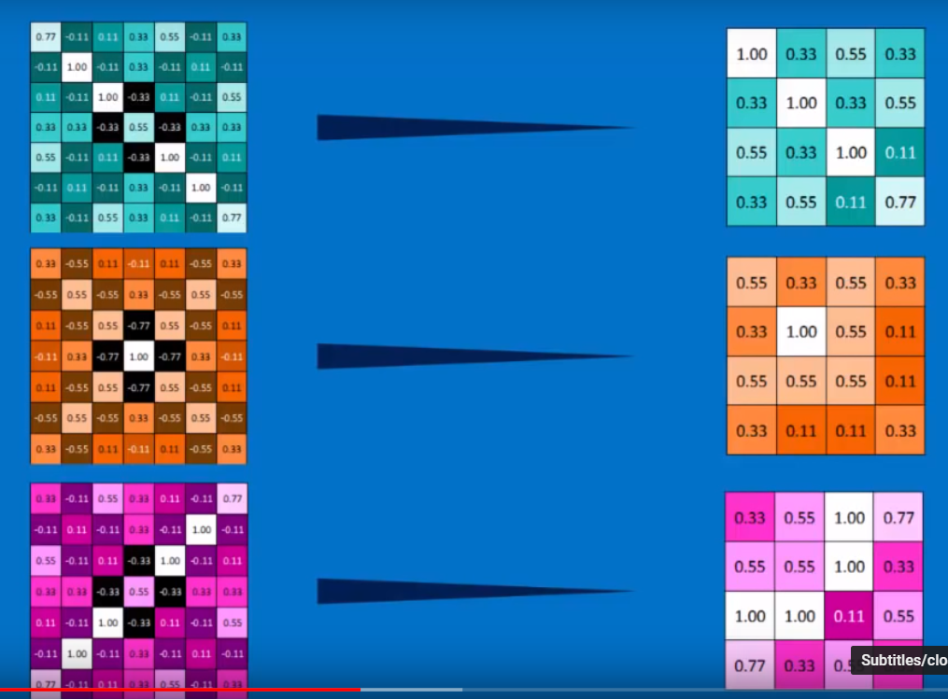

**Deep Learning Traditional methods**

Generally in the final layers we use dropout with 50% wheras in initial layers we use 10-25%.

**Convolution Neural Networks:**

Mean subtraction is used to help combat illumination changes in the input images in our dataset. We can therefore view mean subtraction as a technique used to aid our Convolutional Neural Networks.

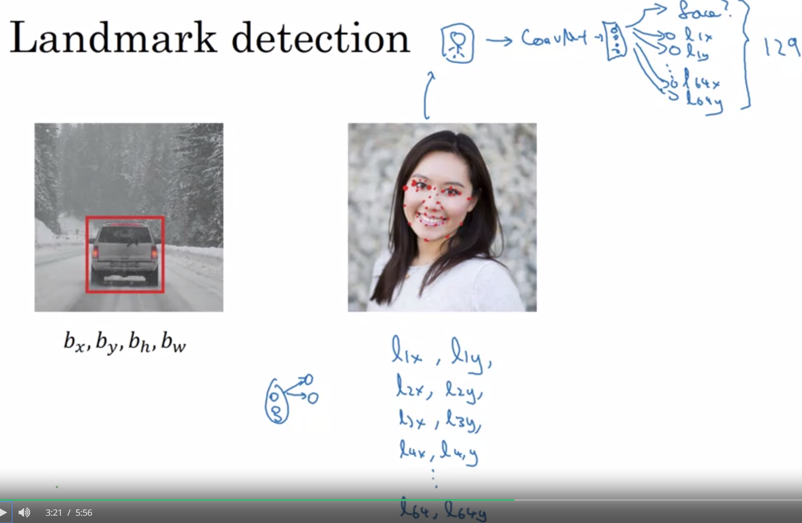

**In case of object localization problem , we change our final layer to predict bounding box coordinates as well. For eg: In case if we want to predict x,y,h,w along with class label our output layer will consist of 4+1 neurons.**

**OpenCV:**

In many image processing pipelines, we must blur an image to reduce high-frequency noise, making it easier for our algorithms to detect and understand the actual contents of the image rather than just noise that will “confuse” our algorithms.

**Thresholding:**

Image thresholding is an important intermediary step for image processing pipelines. Thresholding can help us to remove lighter or darker regions and contours of images.

**Erosion and Dilation:**

Erosion and Dilation are used to remove noise from the image.

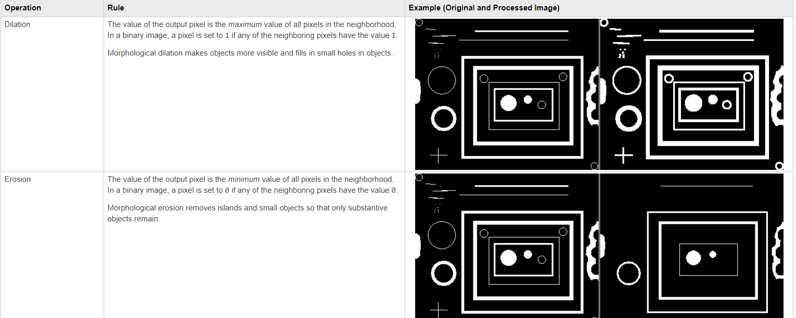

**Object Detection:**

**Single Shot Detector:**

Architecture: VGG network without FC layers + auxiliary convolution layers.

Input for training: Input image with class label and bounding boxes.

Step 1: The input image is made to pass through the VGG base networks and the resulting feature maps are captured.

Step 2: The above obtained feature maps are sent to auxiliary convolution layers. (Convolution is applied by preserving the feature map size).

Step 3: Using the feature map obtained from Step 2. At each cell of this feature map Sliding window with multiple scales and aspect ratio are used to obtain sliding window regions. Each of this sliding window regions are used to obtain a prediction for object and if object is present then overlapping is checked with the ground truth value.

Step 4: Loss is calculated which is combination of softmax loss and l2-loss for bounding box coordinates. Loss is backpropagated accordingly.

Doubts: For each of the sliding window region how is network predicting the class labels? I can see a fully connected layer for each of the convolution layer but can you explain me how this is functioning?

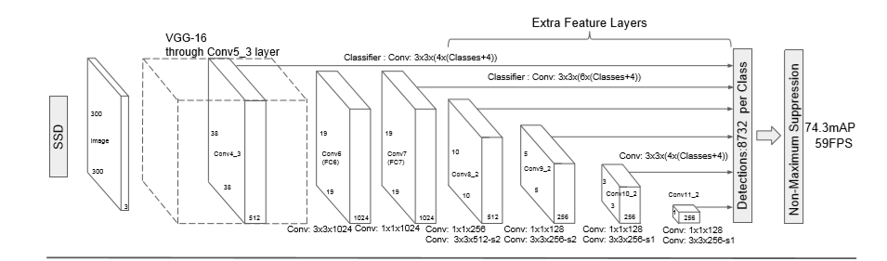

**Convolution Encoder:**

**An autoencoder is a combination of two parts: an encoder and a decoder. The encoder and decoder of a simple autoencoder are usually made up of dense layers, whereas in a convolution autoencoder, they are made of convolution layers:**

**More about convolution in Python Deep Learning project pdf in downloads**

<https://github.com/PacktPublishing/Python-Deep-Learning-Projects>

Hyper Parameters for YOLO:

The anchor box sizes are one of the hyper parameters and the best anchor box sizes can be obtained by using K-Means clustering.

Reference: <https://fairyonice.github.io/Part_1_Object_Detection_with_Yolo_for_VOC_2014_data_anchor_box_clustering.html>